# SUBMISSION GUIDELINES

1. Participating teams are to submit a) 1 project report that describes your project using the given *Project Write Up* and b) 1 poster Submission of the team’s design.
   1. Project Write Up: Please ensure that your submission adheres to the following guidelines stated in the *Project Write Up*.
   2. Poster Submission: The poster submission (up to 2 pages) will be used as a presentation board to the judges to summarize your project. Poster size, style (use of infographic, charts, pictures) and content are left to the discretion of the team. All fonts used inside the poster submission should not be smaller than **Calibri font size 12 and resolution to be at least 200dpi.** The team may choose to upload the poster in png, jpeg or pdf.
2. Each team is to submit the following documents to the Survey Department:

|  |  |
| --- | --- |
| **Documents to be submitted** | **Submission Details** |
| Project Write Up | To submit one per team |
| Poster Submission | To submit one per team  The poster submission (up to 2 pages) will be used as a presentation board to the judges to summarize your project. Poster size, style (use of infographic, charts, pictures) and content are left to the discretion of the team. All fonts used inside the poster submission should not be smaller than Calibri font size 12 and resolution to be at least  200dpi. (.pdf format only) |
| Team Photo | Group photo of all team members  (.jpeg, .jpg, .png formats only) |
| Declaration Form on the Originality  of Work | Duly completed and signed as a team  (.doc, .docx formats only) |

# RULES AND REGULATIONS

1. The submitted project should evidently showcase the use of geospatial technology and information to support nations in achieving their Sustainable Development Goals (SDGs). Details about the SDGs, set out by the 2030 Agenda for Sustainable Development (Figure 1), can be found [here](https://sdgs.un.org/goals).
2. Teams can determine their own challenge statement. The chosen challenge statement should support the SDGs. Teams are encouraged to tap on the additional resources contributed by the challenge partner for their project. Limited slots are available and on a first-come-first serve basis.
3. Each team is required to work on only ONE challenge statement and submit ONE *Project Write Up and Poster Submission*. Participants should adhere to the instructions stated in the *Project Write Up* and must not edit or manipulate the template in the *Project Write Up*.
4. Each team must consist a minimum of TWO, to a maximum of FOUR participants.
5. Each team must nominate a student representative to represent the team for purposes of communication with the Organiser on all matters relating to BDGC 24.
6. Participants are only allowed to participate in ONE project submission.
7. BDGC 24 is open to all students who are enrolled on a full-time basis at an Institute of Higher Learning (Tertiary Institution or its equivalent) only.
8. The submitted project must be the team’s original work and has not been previously submitted in another competition or published for any commercial purposes.
9. The team should own or procure the intellectual property rights (including copyright) subsisting in the Background IP and Foreground IP in their submitted projects, or they have the necessary authorisations, permissions and licences for the use of any Background IP and/or Foreground IP owned by third-parties. For more information, please refer to the Terms & Conditions.
10. Participants are encouraged to familiarise themselves with the judging criteria when working on their project submission.
11. Winners of BDGC 24 will be announced and contacted via email.
12. Participants should adhere to all Terms & Conditions stated under BDGC 24.
13. The Organiser reserves the right to disqualify any participant or teams who are found not adhering to the Rules and Regulations of BDGC 24.

*Source: United Nations Department of Economic and Social Affairs (2020)*

**Figure 1: Sustainable Development Goals**

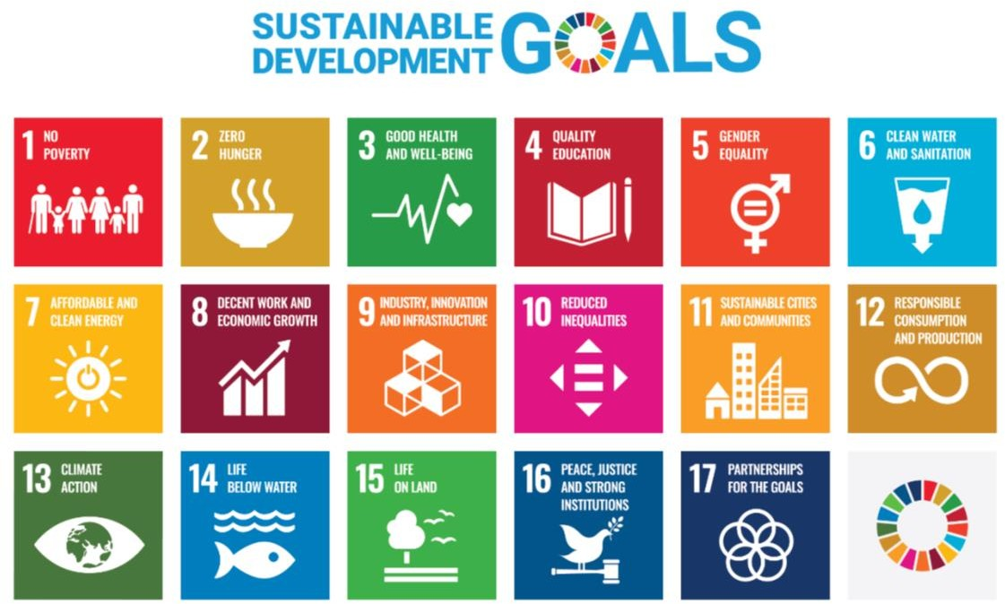

# JUDGING CRITERIA

Participants are encouraged to familiarise with the judging criteria. Below are some guiding pointers and they are non-exhaustive.

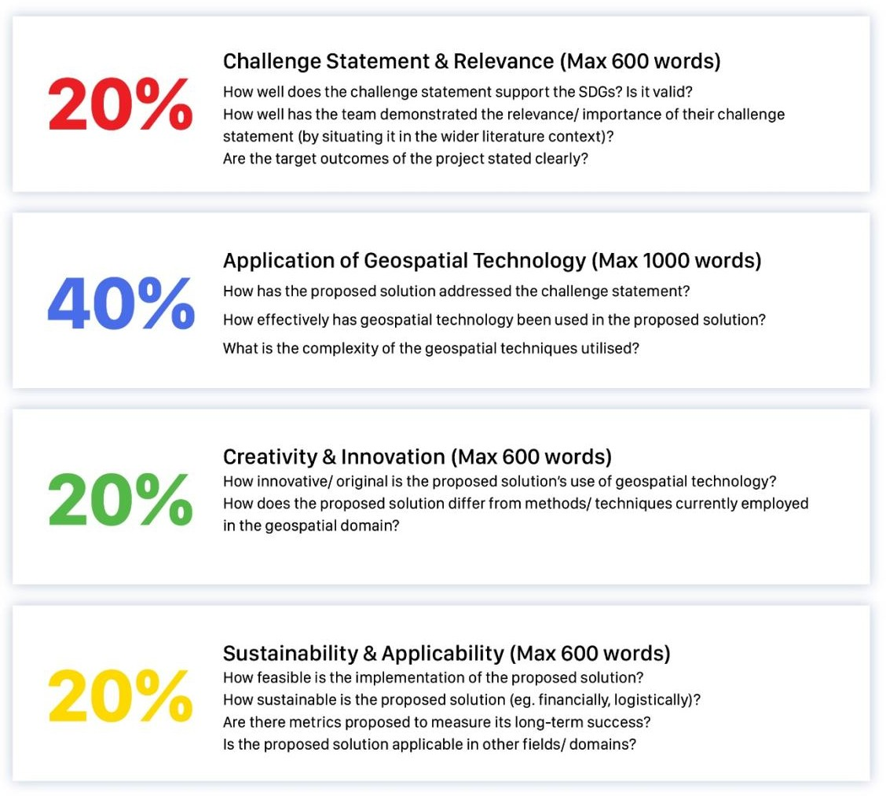

For clarifications, please email [info@survey.gov.bn](mailto:info@survey.gov.bn) (Subject: BDGC 2024).