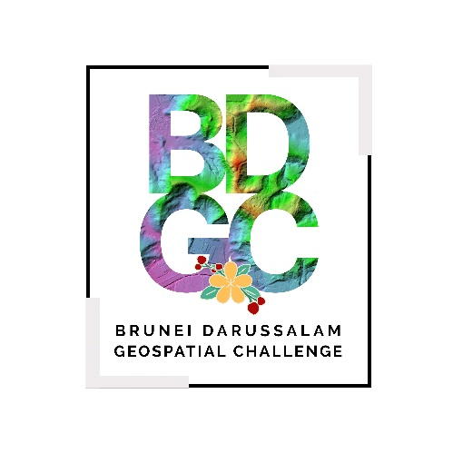 | BRUNEI DARUSSALAM GEOSPATIAL CHALLENGE 2024  DECLARATION OF STUDENT IDENTITY

Team Name | Click or tap here to enter text.
Project Title | Click or tap here to enter text.

I, Click or tap here to enter text. (Participant’s Full Name), hereby affirm that all student information submitted to the Brunei Darussalam Geospatial Challenge 2024 in my application is true and accurate. I further affirm that I am a current full-time student enrolled in Click or tap here to enter text. (Name of Educational Institution) as at 2024/2025.

Signature of Participant: Click or tap here to enter text.
Date: Click or tap to enter a date.

