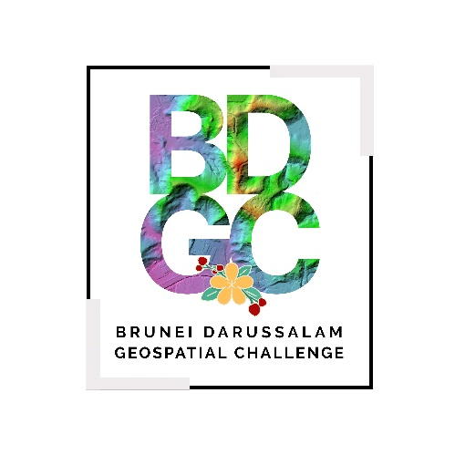 | BRUNEI DARUSSALAM GEOSPATIAL CHALLENGE 2024  DECLARATION OF ORIGINAL WORK

Team Name | Click or tap here to enter text.
Project Title | Click or tap here to enter text.

I, Click or tap here to enter text. (Participant’s Full Name), hereby declare that the above-mentioned group project title (hereinafter “Submitted Work”) submitted by my team for the Brunei Darussalam Geospatial Challenge 2024 is our original work, not copied from other sources and has not been previously entered in any other competitions. I further declare that this Submitted Work has not been previously published for any commercial purposes, and we either own the intellectual property rights (including copyright) subsisting in the Background IP and Foreground IP, or we have the necessary authorisations, permissions and licences for the use of any Background IP and/or Foreground IP owned by third-parties.

I confirm that my team has also procured the necessary authorisations, permissions and licences for the use of the third-party Background IP and/or Foreground IP by the Organiser in accordance with paragraph 3 stated in the Terms & Conditions of the Challenge.

Signature of Participant: Click or tap here to enter text.
Date: Click or tap to enter a date.

